**Stakeholders Engagement & Communication Plan**

1. **Stakeholders:**
   1. Team members building the app (developers, testers, designers, etc)
   2. Project Sponsor
   3. Customers using the app
   4. Marketing team
   5. Offer providers (restaurants, stores, clinics, medical centers, etc)
2. **Stakeholder Analysis:**

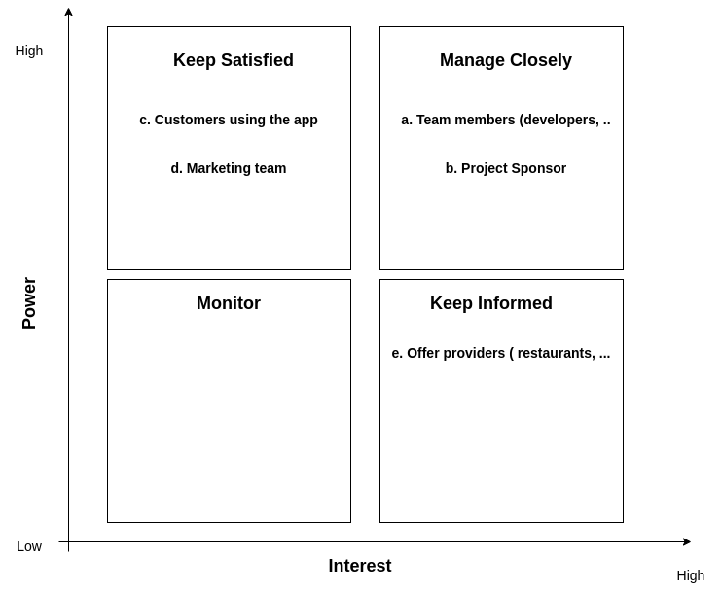

1. **Stakeholder Engagement Matrix:**

| stakeholder | Unware | Resistant | Neutral | Supportive | Leading |
| --- | --- | --- | --- | --- | --- |
| team members |  |  |  |  | C D |
| project sponsor |  |  |  | C D |  |
| customers | C |  |  | D |  |
| marketing team |  |  |  | C D |  |
| offer providers |  |  | C | D |  |

1. **Communications Management Plan:**

| Purpose | Responsibility | Audience | Medium | Content | Frequently |
| --- | --- | --- | --- | --- | --- |
| Team Status | PM | team members | Meeting | SV, Issues, Risks, Ask | Weekly |
| Project Status Report | PM | Project Sponsor | Meeting | SV, Demo, Issues, Ask | Bi-Weekly |
| Improve Project | QA | Customer | Email | Issues, Improvements | Weekly |
| market project | PM | Marketing Team | Meeting | Demo, Ask | Monthly |
| Project Status | - | Offer Providers | Meeting | Demo, Ask, Issues | Bi-Weekly |
| Audit | QA | PM, Team | Meeting | Compliance, Issues, Risks | Monthly |